**ITSP200 – Deliverable 5: User Manual**

|  |  |
| --- | --- |
| **Group number and name** | Group 4 –The Poll makers |
| **Group member details** | J6H6SY5M7 – Jansen; Nadine (Leader)  P4PXK2T59 – Gumede; Luyanda  BXMDLL7W9 - Mtshatsheni; Nompumelelo |
| **Project title** | Advanced Polling System |
| **Submission date** | 22/10/2019 |
| **Signature of group leader** | N. Jansen |

**Advanced Polling System**

**USER MANUAL**

**Developed by [Poll Makers]**

Contents

Introduction 4

Group contact information 4

Getting Started 4

How to install 4

Instructions 4

Glossary 10

Customer sign-off 10

# Introduction

The Advanced Polling System is a voting system, whereby students select a suitable candidate for SRC. Below is a table of contact information if you require any further assistance.

# Group contact information

|  |  |  |
| --- | --- | --- |
| **Name and Surname** | **Contact Number** | **Email address** |
| Nadine Jansen | 061 465 5864 | njansen990@gmail.com |
| Luyanda Gumede | 072 112 5937 | 2aubreylg12@gmail.com |
| Nompumelelo Mtshatsheni | 079 035 2734 | nompumelelomtshatsheni@gmail.com |

# Getting Started

## How to install

Screenshots and briefly explaining upon how to install the system, this will be illustrated below the instructions heading.

### Instructions

**1: Registering a new student**

Step1: The user will be presented with the welcome screen. The user will select the register button, to register themselves onto the system.

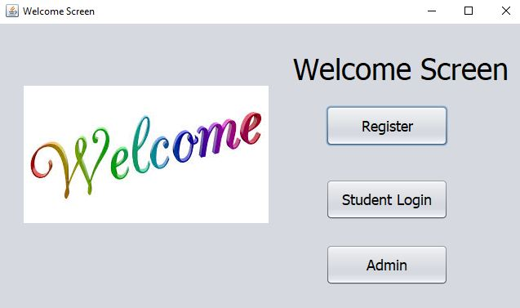

Step2: The user should fill in all relevant information and click “Next”. If you want to return to the previous screen click “Back”.

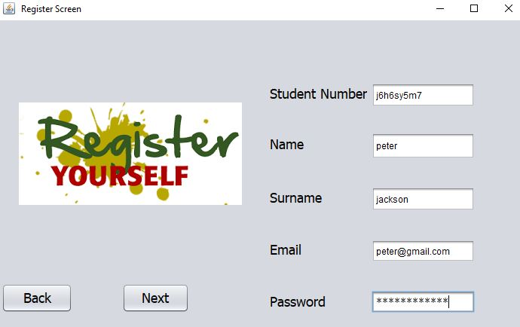

Step3: The user should fill in all relevant information and click “Login”, if the user wants to return to the previous screen click “Back”.

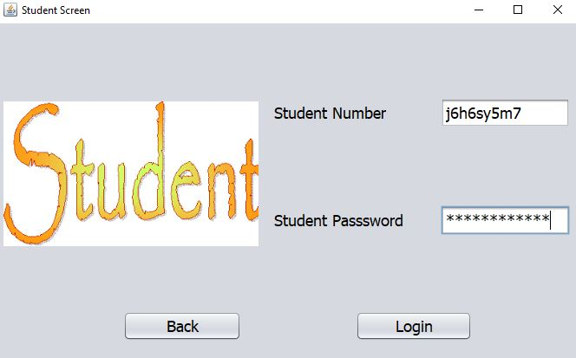

Step4: The user is required to only select one suitable candidate from each given position, after selecting the suitable candidate, the user should click on “Vote”, but if you wish to return to the previous screen click “Back”.

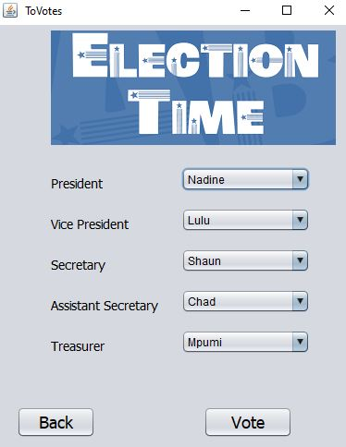

Step5: The finish screen will be displayed, indicating that the voting has been completed, click “Exit” and the welcome screen will be displayed for the next user to cast their vote.

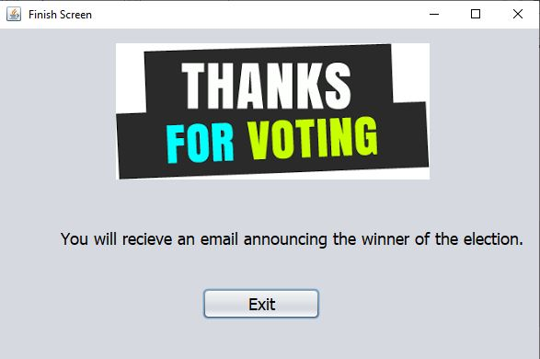

**2: Admin login**

Step1: Admin will be presented with the welcome screen and should click on “Admin”.

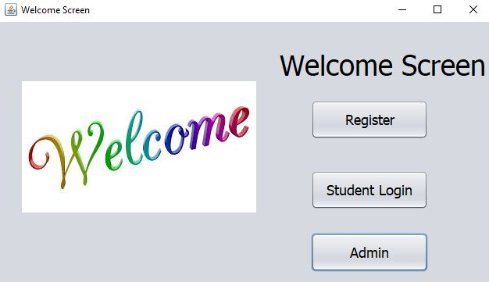

Step2: Fill in relevant information and click “Login”, if admin wants to return to previous screen click “Back”.

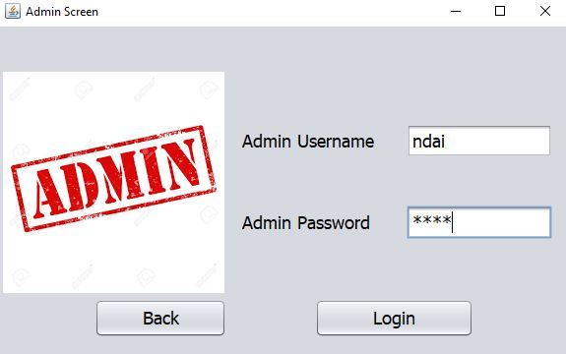

Step3: The database screen will be displayed, which allows admin to manipulate data. If admin clicks “Candidate Information”, all relevant information of candidate’s is displayed and etc or click “Back” to return to the previous screen.

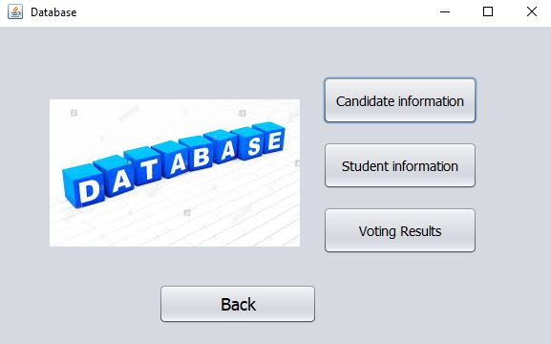

Step4: The candidate information displays all relevant data about the candidates and it allows admin to manipulate the candidate’s data. Click “Back” to return to the previous screen.

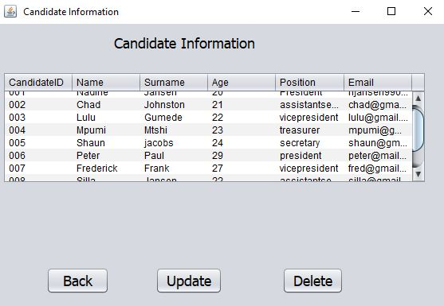

Step5: The student information displays all the registered student’s information. Click “Back” to return to the database screen.

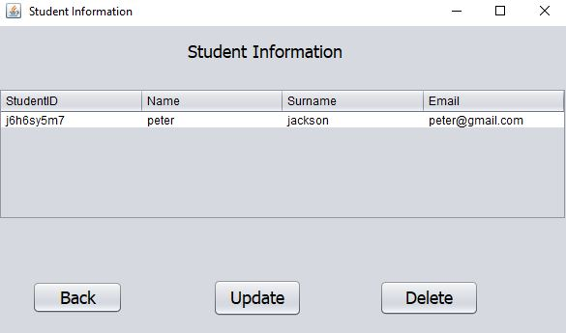

Step6: The voting results allows admin to see which candidate was casted the most votes. Click “Back” to return to the database screen.

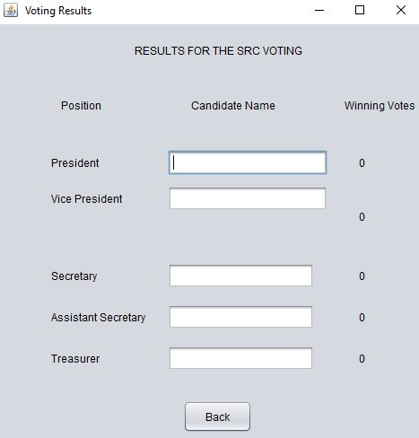

# Glossary

* SRC – Student Representative Council.

# Customer sign-off

|  |  |
| --- | --- |
| **Customer name and surname** | **Customer signature** |
| **Group leader name and surname**  Nadine Jansen | **Group leader signature**  N. Jansen |